%Kai Jin

% A little statistics

%1.B

%I try three different x values -- 1, 2 and 3 to find probability from -Inf

%to x which the mean of normal distribution is 0

pb = {normcdf(1,0,1), normcdf(2,0,1), normcdf(3,0,1)};

pb =

1×3 cell array

{[0.8413]} {[0.9772]} {[0.9987]}

%1.C

%I try to make the inverse probability match x values 1, 2 and 5

sigma = {norminv(0.84134), norminv(0.97725), norminv(0.9999997134)};

sigma =

1×3 cell array

{[1.0000]} {[2.0000]} {[5.0000]}

%1.D

%We set the mean at 0, therefore, if a posibility is less than 0.5 its

%reverse sigma value will be less than 0

%2.A

x = linspace(0,10,100000);

logN = makedist("Lognormal",'mu',0.5, 'sigma',0.8);

%2.B

figure()

subplot(1,2,1)

plot(x,pdf(logN,x),"LineWidth",4)

title('Lognormal distribution')

subplot(1,2,2)

plot(x,pdf(logN,x),"LineWidth",4);

set(gca,'YScale','log')

title('Lognormal distribution with logY value')

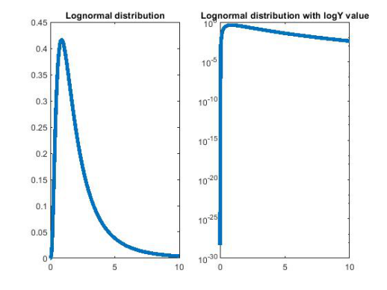

%3.A

% My hypothetical measurement is at x=6 of background distribution

%3.B

%The signal I found always lay on the region x>6 of background

%distribution. What's the probability I can find the signal from the

%background?

%3.C

%pb = 1 - integral(logN, -Inf, 6)

%3.D

pb2 = 1 - cdf(logN, 6);

pb2 =

0.0532

%3.E

sigma2 = norminv(1 - pb2);

sigma2 =

1.6147

%4

%For 4

pb3_1 = 1 - cdf(logN, 4);

pb3_1 =

0.1340

sigma3_1 = norminv(1 - pb3_1);

sigma3_1 =

1.1079

%For 5

pb3_2 = 1 - cdf(logN, 5);

pb3_2 =

0.0828

sigma3_2 = norminv(1 - pb3_2);

sigma3_2 =

1.3868

%For 7

pb3_3 = 1 - cdf(logN, 7);

pb3_3 =

0.0354

sigma3_3 = norminv(1 - pb3_3);

sigma3_3 =

1.8074

%It shows that the probability of right side of lognormal distribution

%has a reverse relationship to sigma

% Non-continuous distributions

%1.A

x = 0:10;

poisson = makedist("Poisson", 'lambda',3);

%1.B

figure()

subplot(2,2,1)

stairs(x,pdf(poisson,x),"LineWidth",4);

poisson = makedist("Poisson", 'lambda',1);

subplot(2,2,2)

stairs(x-0.5,pdf(poisson,x),"LineWidth",3);

poisson = makedist("Poisson", 'lambda',2);

subplot(2,2,3)

stairs(x-5,pdf(poisson,x),"LineWidth",1);

poisson = makedist("Poisson", 'lambda',4);

subplot(2,2,4)

stairs(x-10,pdf(poisson,x),"LineWidth",3);

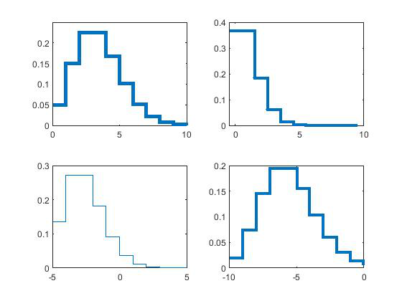

%For stairs function

%The first parameter indicates the start point of x-axis

%The second parameter is the distribution data

%The third parameter add control to line width in the graph and last

%parameter decides the line width

%For makedist function

%First parameter indicates type of distribution

%Second parameter determine the location of highest value of poisson

%distribution

%Third parameter is the exact location where the middle of highest

%stair. It cooperate with second parameter.

%1.C

%Find the probability between x=5 and x=7

pb4 = cdf(poisson, 7) - cdf(poisson, 5);

pb4 =

0.0720

%1.D

%The probability of distribuyion is the area under its graph, we can only

%choose the integer x value, therefore, the area(probability) is also

%discrete. This is harder for us to estimate the value outside of current

%data and find trnd line of data set.

%1.E

%The mean value in poisson distribution is the expect value of random event

%that means there are more probability when it's closer to average value,

%it doesn't mean average value situation must happen.